**DISCRETE MATHEMATICS – FALL 2019**

**Final Exam – Code 01**

**90 minutes**

**ID:** …………………  **Name:** ……………………………………………….. **Class:** …………

**Instructions:** Fill in your student ID, name and class. Then submit this paper along with your answer at the end of the exam.

**Question 1:**

Let P(x) be “x is perfect”, let F(x) be “x is your friend” and let the domain be all people.

Translate each of these statements into logical expressions using predicates, quantifiers, and logical connectives.  
**a)** No one is perfect.  
**b)** Not everyone is perfect.  
**c)** All your friends are perfect.  
**d)** At least one of your friends is perfect

**e)** Everyone is your friend and is perfect.  
**f)** Not everybody is your friend or someone is not perfect

**Question 2:**

Prove that 12 - 22 + 32 - … + (-1)n-1 n2 = (-1)n-1 n(n+1)/2 whenever n is a positive integer.

**Question 3:**

We received data through a transmission line with general error rate is 1 over 5 packages. The received packages are {1; 1; 0; 3; 3} and the encryption employs polynomials over *GF*(7). Write a detailed solution to find what the corrected value of the error package is?

Note: We have the equation:

$$A* \left(\begin{matrix}a_{3} \\ a_{2} \\ a_{1} \\ a_{0} \\ b_{0}\end{matrix}\right)=B$$

The inverse matrix A-1 is:

|  |  |  |  |  |
| --- | --- | --- | --- | --- |
| 7/50 | -3/25 | 1/100 | -11/50 | 19/100 |
| -3/10 | 2/5 | 1/20 | -1/10 | -1/20 |
| -1/10 | -1/5 | -3/20 | 3/10 | 3/20 |
| 3/50 | 13/25 | 129/100 | 31/50 | -149/100 |
| 1/5 | -1/10 | -1/5 | -1/10 | 1/5 |

**Question 4:**

What is the original message encrypted using the RSA system with p=5, q=11 and e=27 if the encrypted message is 21 36 23 05 01 49? Translate the original message to letters (A through Z corresponds with 01 through 26)

**Question 5:**

Use Dijkstra’s Algorithm to find the shortest path from A to other vertices.

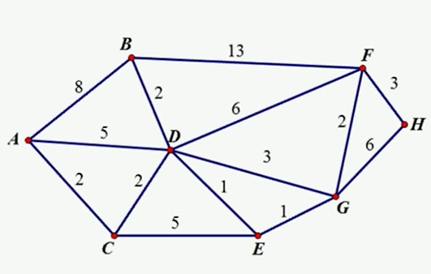

***-----The end-----***